Designated Centre
Statement of Purpose

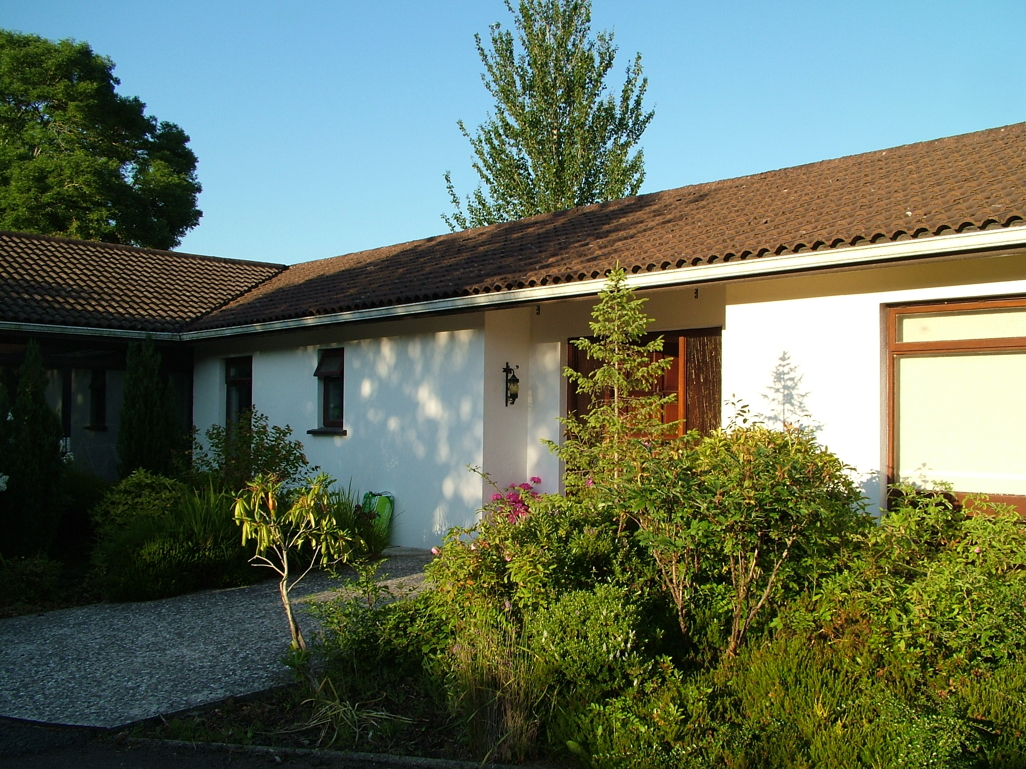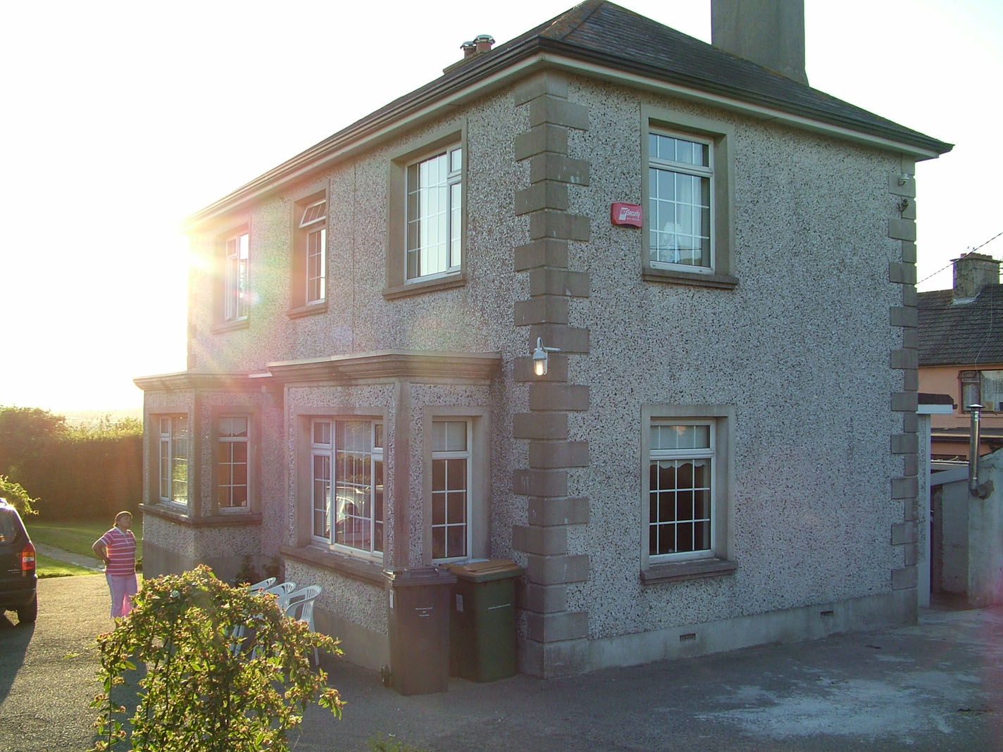

Holly Lodge Ard Alainn
Millbanks Hospital Road
New Ross New Ross
Co. Wexford Co. Wexford

June 2016

Designated Centre Details

Name of centre: Cumas New Ross

Address of centre: New Ross, Co. Wexford

Telephone number of centre: 051 448063

E-mail Address: info@cumas.ie

Website of centre: www.cumas.ie

Aim:

To provide a community living setting, to live as near as possible in a family lifestyle
wherein residents are provided with support, dignity and respect within a caring
environment that promotes the health and wellbeing of each individual.

Objectives:

- To provide a home environment as near as possible to a family lifestyle

- To provide a high standard of needs based support in accordance with best practice

- To ensure each individual resident lives within a safe, homely and clean environment

- To ensure each individual resident is free from all forms of abuse including peer to peer abuse

- To respond to the changing and developing needs of each individual resident as appropriate

Ethos:

Cumas will strive to ensure that the rights of each individual resident are upheld, including a right to equality, dignity, respect, privacy and safety. Cumas will also strive to ensure that each resident can be supported to maintain a sense of individual identity and ownership of their own lives.

Facilities: Holly Lodge

Holly Lodge | Size | Occupancy
Bedroom 1  Ensuite | 11.6m²  7.6m² | 1
Bedroom 2  Staff Room | 9.1m² | 1
Bedroom 3 | 9.7m² | 1
Bedroom 4  Ensuite | 13.7m²  4.4m² | 1
Bedroom 5 | 9.5m² | 1
Bedroom 6  Respite | 12.7m² | 1
Bedroom 7 | 11.4m² | 1
Kitchen | 16.96m² | Communal
Dining Room | 12.48m² | Communal
Lounge | 24.8m² | Communal
Conservatory | 6.72m² | Communal

Facilities: Ard Alainn
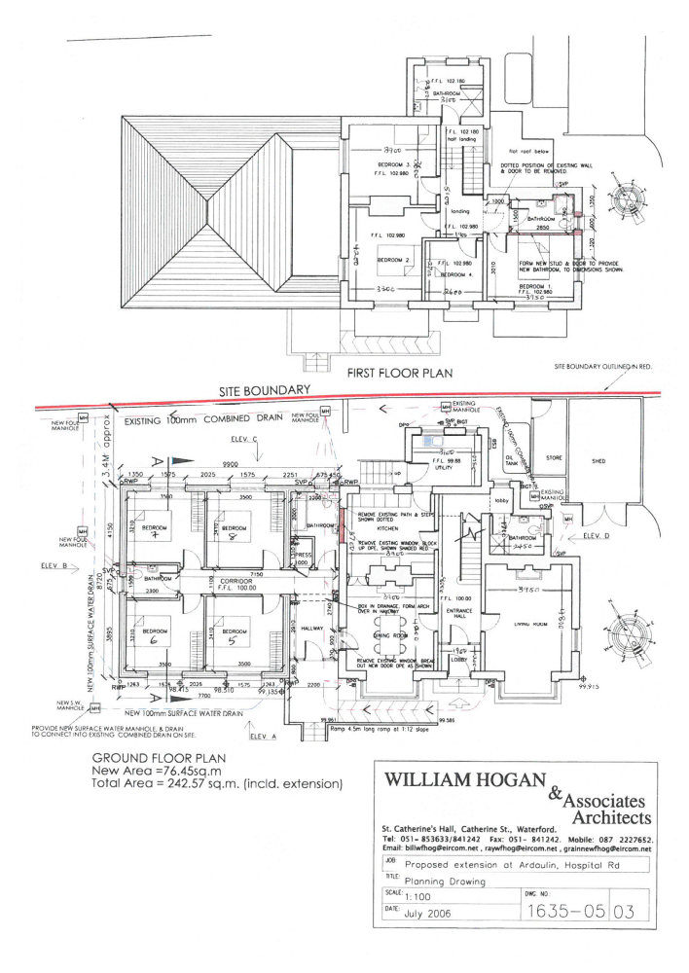

Ard Alainn | Size | Occupancy
Bedroom 1 | 11.9m² | 1
Bedroom 2 | 13.9m² | 1
Bedroom 3 | 14m² | 1
Visitors Room | 7m² | 0
Bedroom 5  Staff Room | 11.9m² | 1
Bedroom 6 | 11.2m² | 1
Bedroom 7 | 11.2m² | 1
Bedroom 8 | 11.9m² | 1
Kitchen | 14.43m² | Communal
Dining Room | 16.38m² | Communal
Lounge | 18.96m² | Communal

Services:

Cumas provides residential care for 11 residents of mixed gender and one respite room for use by individuals from Cumas Day Service only. The service is provided from 3:45pm to 9:45am Monday to Friday and from 3:45pm Friday to 9:45am Monday. The service is also provided during the daytime hours on bank holidays and holiday/day service closures. The Residential Service closes for Christmas from noon on Christmas Eve and reopens at 5pm on the 27th December each year.
Transport is provided for the use of the residents.
All residents attend the Cumas New Ross Day Service which is open from 9am to 4pm Monday to Friday. The Day Service closes for specific holidays which is agreed with the attendees at the beginning of each year and a schedule of closures is provided to residents. Any closures for training/strategic days are made with advance notice and the Residential Service remains open for residents.
Registered Provider

Name: Co. Wexford Community Workshop (New Ross) Limited trading as Cumas New Ross

Principal Address: Butlersland Industrial Estate, New Ross, Co. Wexford

Principal Telephone Number: 051 448063

E-Mail Address: info@cumas.ie

Provider Nominee

Name: Robert Smith

Principal Telephone Number: 051 448086

Alternate Telephone Number: 086 4177799
E-Mail Address: rsmith@cumas.ie

The Person in Charge

Name: Anne Keenan

Principal Telephone Number: 051 448085
Alternate Telephone Number: 086 4060047
E-Mail Address: akeenan@cumas.ie

In the absence of the Person in Charge

Name: Robert Smith

Principal Telephone Number: 051 448086
Alternate Telephone Number: 086 4177799
E-Mail Address: rsmith@cumas.ie

The Management Team

Fiona O’Brien Team Leader/Social Care Worker

Ann Marie Fahey Team Leader/Social Care Worker

Robert Smith General Manager

Anne Keenan Services & Quality Manager, Fit Person and Designated Person

Registration Details

Organisation Identification: OSV 0004739

Registration Number: Awaiting

Date of Registration: Awaiting

Expiry Date of Registration: Awaiting

Capacity of the Centre

Total 12 persons comprising: 11 people @ 7 Day Residential and 1 Respite

Total Staffing Complement including Multi Disciplinary Supports

Position | Number  Employed  **Accessed through Community Services (HSE) | Whole Time  Equivalent | Details
Social Care Worker(s) | 8 | 6 | Social Care workers rostered for duty, including sleep over.
Nursing  (RNID) | 1 | .25 | Nursing support is based within Day Services with direct support to residential timeframe when required
**Social Work |  |  | Provided by HSE Community Services via day services.
**Occupational Therapist |  |  | Provided by HSE Community Services via day services.
**Alternative Therapies | Sessional |  | Accessed by individual residents within day and residential
Driver | 1 | .4 | Drivers are assigned to day services and are involved in transport from residential to/from day services. Residential staff avail of transport assigned to the house.
**Psychiatry | 1 | .1 | Provided by HSE Community Services via day services
**Psychology |  |  | Provided by HSE Community Services via day services
**Physiotherapy |  |  | Provided by HSE Community Services via day services.
**General Practitioner |  |  | Accessed by residents on an as needs basis through GP Practices
**CareDoc |  |  | Out of hours GP Service
**Opthalmic Services |  |  | Accessed by individuals on an as needs basis
**Dentist |  |  | Accessed by individuals on an as needs basis
**Counselling |  |  | Accessed by individuals on an as needs basis
**Audiologist Services |  |  | Accessed by individuals on an as needs basis

Organisational Structure
Cumas New Ross

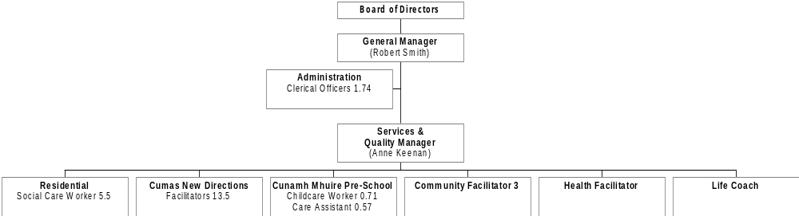

Profile Information of Residents

Age Range | Sex | Number | Facilities  Provided
18+ yrs | Females & Males | 11 Residential  1 Respite | Community residential: All residents have their own bedroom.
Specific Care and Support Needs
All residents have a low dependency in terms of support needs. This facility provides services and support to people with intellectual disability who may have additional needs associated with having an older age profile and includes the following areas of support:
- Physical mobility
- Sensory needs
- Communication needs
- Intellectual needs
- Behavioural supports
- Social needs
- Medical needs
- Administration of medication
- Personal Emergency Evacuation Procedure
- Person Centred Plans
- Bereavement support
- Money Advice and Budgeting

Admission Policy
Application for admission is through a referral process that is outlined in the Application and Admission Procedure – Residential. In order to be considered for admission potential residents must complete the Residential Application Form and sign the Residential Consent Form. If a potential resident has not previously availed of respite in our service and they are deemed as the most likely candidates for the placement, they will be offered a trial placement following introduction to the other residents and visiting the house. A meeting is then held with the other residents of the relevant house to obtain their feedback regarding the potential new resident. Their input is then fed into the Assessment Panel and is the primary determining factor as to whether a placement is offered.
Prior to admission the resident must provide a completed Residential and Respite Accommodation Information Form and a Medical Details Form completed by their G.P. All items on the Residents Admission Checklist must also be confirmed as complete, the Contract of Care is outlined and a signed Tenancy Agreement is put in place.
The criteria for admission are that applicants will be 18 years of age and over, primarily diagnosed with a mild or moderate intellectual disability and must have independent mobility capability. The applicant (not a family member or carer) is required to give written consent of their wish to be considered, indicating that they would wish to live in New Ross.
Emergency admissions for residential placement are not accepted. Should a resident’s changing needs reach a level whereby permanent high support is required a different type of service will be sourced and the resident supported in the transfer and discharge process as outlined in the Application and Admission Procedure – Residential. Examples of high support include but are not limited to medical/mental health needs requiring onsite nursing care and/or 24/7 support, ongoing challenging behaviours of a frequency, duration and intensity that severely impacts the quality of life and safety of the other residents.

Leisure and Social Activities and Opportunities
The following leisure and social activities are offered to all residents on a weekly basis:
- Dining out
- Drinks out and music nights in local public houses
- Grocery shopping
- Shopping trips
- Visits to other peer residents’ homes
- Church
- Cinema
- Beautician
- Hairdresser
- Personal shopping
In addition to the above, each resident has a minimum of one mini break, one holiday per annum and overnight trips to Theatre/Concerts in various parts of the country. Each resident also has the option to attend the various entertainment options offered in St. Michaels Theatre, New Ross.
Access to Relatives, Friends and Representatives
Residents are actively encouraged to maintain all forms of social contact that they enjoyed before moving in and are encouraged to establish new social networks also. Each resident is encouraged to maintain contact with their family if they wish to do so. Families, in accordance with the resident’s wishes are encouraged to participate in the development of the resident’s Person Centred Plan and Care Plan and scheduled reviews. Visitors are, within reason, generally welcome at any time, provided the rights of other residents are not compromised in any way. Residents have access to phones and mobile phones in order to support them to maintain contact with family and friends. In addition the Centre is WiFi enabled and a computer is present for the use of the residents to enable email and online access to family and friends.
Staff will ensure that:
- Arrangements are in place for residents to receive visitors.
- In so far as is practicable, there will be no restrictions on visiting times except when requested by the resident.
- Any restrictions placed on visiting times by the Designated Centre will be communicated to the resident/resident’s representative.
- A Visitor’s Book is present for all Visitors to sign in/out.

Access to Training, Education and Employment
All of the residents living within the Residential Service have daily access to Cumas New Ross Day Services. Their Day Service is customized to their individual needs including access to the community on a continuous basis.

Participation and Consultation
Each individual resident is supported and encouraged to have as much influence and ownership of their own life as is possible. This is striven for through the ongoing relationship between each resident, house staff and day servicefacilitators, who through their work have built up an in-depth knowledge of the needs, likes, wishes and preferences of each resident. The day and residential services have undergone a complete reconfiguration in line with New Directions over the past two years which means that the ethos of Individualisation Towards a Better Life is being worked through with each resident on a one to one basis. This updated process is intended to facilitate an even greater depth of knowledge to ensure that the views, wishes and preferences of each resident are captured, monitored, reviewed and acted upon. Residents are supported in exercising their right to vote if they so choose.

Fire Precautions and Procedures
All Staff receive Fire Safety Awareness and Use of Extinguishers Training.
Each resident will have a Personal Emergency Evacuation Procedure (PEEP) developed with them in a format that is accessible to them. The PEEP will be used as part of the regular Fire Evacuation Drills. Each resident will review their PEEP with the house staff in the week following the drill and make any changes identified.
For further information please refer to the Ancillary Safety Statement.

Religious Attendance and Observation of Preferences
All residents individual religious preferences are acknowledged, observed and facilitated in terms of religious observance, including attendance at religious ceremonies where desired.

Dealing with Complaints
Précis of Cumas New Ross Complaints Information and Procedure
Definition of a complaint
A complaint is a claim about any action of the organisation that does not accord with fair or sound administrative practice, and adversely affects the person by whom or on whose behalf the complaint is made. (Health Act 2004).
Purpose
The purpose of this procedure is to allow any person who was or is being provided with a service by the organization or who has sought or is seeking provision of such service to complain about any action of the organization that is claimed:
(a) Does not accord with fair and sound administrative practice, and
(b) Adversely affects or affected that person.

Who can make a complaint
Any person who is being or was provided with services from Cumas New Ross or who is seeking or has sought provision of such service may complain.

How complaints can be made
A complaint can be made verbally or in writing by letter, fax or email to Robert Smith, General Manager, Cumas New Ross. A Complaints Form is also available from the Designated Centre and Cumas New Ross for this purpose.

Acknowledgements
On receipt of a complaint the responsible company officer shall acknowledge receipt to the complainant in writing within 5 working days. The letter will outline the steps that the officer proposes to take in investigating the complaint and the time limits for the completion of the investigation. (Health Act 2004).

Advocacy
All complainants have the right to appoint an advocate. Where a person is unable to make a complaint themselves an advocate can assist them in making the complaint.

Stages of the Complaints Management Process
There are five stages in the management process:
Stage 1: Local resolution of verbal complaints at point of contact (Informal).

Stage 2: Local investigation of written and serious complaints (Formal).

Stage 3: Internal Review
If a complainant is not happy with the outcome of a complaint, they are entitled to seek an internal review by someone independent of the original investigation that would normally be the General Manager or Chairperson of the Board of Directors if the General Manager was the Investigating Officer. When making such a review request, the complainant should detail the aspect(s) of the original report that they have issue(s) with.

Stage 4: External Review (Health Service Executive)
If a complainant is not happy with the result of their internal review, they have a right of appeal to the Health Service Executive for an external review of their complaint. The request should be made in writing to the Area Co-ordinator Disability Services, Georges Street, Wexford, Co. Wexford.

Stage 5: Independent Review (Ombudsman)
If a complainant is not happy with the result of their external review, they have a right of appeal to the Ombudsman for an independent review of their complaint. The written request should be forwarded to the relevant office:
Office of the Ombudsman, 18 Lower Leeson Street Dublin 2
Office of the Ombudsman for Children, Millennium House, 52-56 Great Strand Street, Dublin 1
Complaint Form

Cumas New Ross, Butlersland Industrial Estate, New Ross, Co. Wexford

Please outline the nature and any relevant information regarding your complaint below:

Complainant Signature: Date:

Please forward this Complaint Form to:
Robert Smith
General Manager
Cumas New Ross
Butlersland Industrial Estate
New Ross
Co. Wexford

Complaint Form Received Date:

Signed: Date:

Person Centred Plans and Processes
Each resident holds their own Person Centred Plan and has the ongoing opportunity to participate in a person centred process that empowers the individual to share information detailing their own wishes, needs and aspirations.
The system of person centred processes has been updated since the reconfiguration of the service in line with New Directions and is now being worked through with each resident on a one to one basis. This updated process is intended to facilitate an even greater depth of knowledge to ensure that the views, wishes and preferences of each resident are captured, monitored, reviewed and acted upon.
In accordance with the wishes of the resident, their families are offered the option of inclusion and involvement in the Person Centred Process and where no involvement is chosen, this will be reoffered on an annual basis.

Care Plans
A plan of care to meet an individual resident’s needs will be devised with the resident and any relevant parties. A copy of the Care Plan will be made available to the resident and, if it is the wish of the resident, to the resident’s parent(s), guardian or designated representative.
Care Plans will be reviewed with the individual resident on an annual basis, at a minimum, as part of a multi-disciplinary review. In addition each resident’s changing needs and overall wellbeing is discussed at the monthly Residential Staff Meeting and any actions identified are implemented in a timely manner.
In accordance with the wishes of the resident, their families will be offered the option of inclusion and involvement in the development and review of the Care Plan and where no involvement is chosen, this will be reoffered on an annual basis.

Therapeutic Interventions
Individual residents are facilitated in making choices regarding access to individual therapeutic interventions that are generally in addition to all needs based required medical and care interventions identified on an ongoing basis for each resident. Examples of additional therapeutic interventions include access and participation in counselling, reflexology and massage.

Privacy and Dignity
It is our policy that residents are treated in a dignified manner that does not embarrass, humiliate or expose them in any way. All residents have their own bedroom that they can lock the door to. All staff respect the resident’s right to privacy and demonstrate this by knocking, asking permission to enter and only doing so with consent. Staff do not enter bedrooms when the resident is not present without their consent. It is important that residents feel that the services and supports we provide for them will be carried out in a manner that respects their privacy and dignity at all times, and they are not subject to or do not experience negative or offensive attitudes from any person. Should a resident require assistance with their personal and/or intimate care, it is carried out in the manner detailed in the resident’s Care Plan and by staff members who are agreed in advance with the resident.

Day Services
Our Mission is Individualisation Towards a Better Life.
Cumas New Ross began as Co Wexford Community Workshop (New Ross) Ltd and were established in 1975 by a group of concerned parents, friends and business people. In 1976 we commenced services in the Legion of Mary Hall in New Ross and in 1978 we moved to new premises at Marshmeadows. Since we opened our doors, we have provided a traditional day service which was split into Sheltered Occupation Services, Rehabilitative Training and Activation.

In 2009/10, we started to change the way we thought about how we should provide services. This thought process was further enhanced throughout 2011/12 when we facilitated three individuals to move from a residential/home setting to living independently. The organisation participated in the Value for Money report (DOH, 2012).

The staff members, families and individuals we support were active participants in the Day Services Review consultation process which further informed the organisation about changes that were indicated by the New Directions report (HSE, 2012).

As a senior management team we knew that change was on the horizon and we were anticipating the publication of New Directions to provide us with a pathway and have also been listening to the individuals we support and their families. We have been aware that the one size fits all model of service provision is both morally and ethically untenable and have been making changes one individual at a time over the past couple of years.

In the second half of 2012 we proposed to completely reconfigure the way we provide service to the individuals we support. Cumas, with the support of Genio, the implementation of New Directions and the need for reform within service provision as directed by government and national policy, decided to take the life changing initiative to embrace individuals who have traditionally received services, to become an equal and integral part of the team of people who shape and facilitate the daily choices and opportunities available. We decided to pay more than lip service to the theory that the individual is the expert on their own lives, actually place them front and centre in all that we do and enable them to become the leaders of change. This new thinking and cultural shift in how services are understood also provides an opportunity to positively influence the societal perceptions that exist around the concept of what disability actually is, which in turn can and will influence national policy. We have also taken a proactive approach to assisting local communities to focus on peoples abilities as opposed to the traditional view of people with disabilities.
Our primary centre was flooded in October 2012 and a four phase move to new premises was developed that reinforced our commitment to change. Phase 1 commenced in January 2013 and was an interim premises that transitioned to a drop in resource centre as the three phases completed. Phase 2 was a learning centre where a simulated environment has been created to facilitate the transfer of skills and build self-confidence/self-esteem. Phase 3 was an artisan type setting where the skilled crafts people we support commenced work on the entrepreneurial skills necessary to own your own business. Phase 4 was the closing of our Phase 1 building and opening the final drop in style centre in our new premises.

In January 2014 we rebranded and are now known as Cumas New Ross (Cumas is the Irish word for ability). Our aims and objectives are in line with New Directions and the implementation plan 2012 – 2016 (HSE, 2012). Our plan is to be a resource for the individuals we support rather than their sole provider. A crucial element of Cumas New Ross is returning control to the experts on the lives of the individuals we support – themselves. The individuals we support are an integral part of the change process and team and their Person Centred Plans are the blueprint that underpins our service.

We continue working to develop networks within individuals’ own communities (of their choice) to fully integrate and include them. This is being facilitated through mainstream resources such as VEC’s, sports clubs, traders associations, chambers of commerce, volunteering and local community groups. The individuals we support are responsible for the organisation and planning of all activities being undertaken by the organisation. Also no activity is being undertaken at present unless it is an activity that the individual would eventually aspire to do without support and is contained in their PCP.

Cumas is recognised as a ground breaking, pioneering and innovative development designed to provide individuals with new and exciting opportunities for their lives that they would not have had access to before. It provides an individualised, person centred and New Directions focused service to support independent access to all services within the individuals’ own rural or urban based community. It is the comprehensive and total restructuring of all elements of the organisation that has brought about a unique transformation to how services are designed, planned and offered to people. It facilitates in real terms a new ownership for the individuals where they actively and directly influence and shape the services they access. In addition, we are beginning the process of planning with individuals in their last year of school, to enable them to set real expectations for their futures that are not limited to accessing the adult disability service that is available to them merely by virtue of geographic location.

Policies, Procedures And Guidelines:

Safeguarding of Adults with a Disability from Abuse in Cumas New Ross. Designated Person Information. Prevention of Abuse Policy. Allegation of Abuse Procedure.

Admissions, including transfers, discharge and the temporary absence of
residents. Application & Admission Procedure – Residential. Residential Application Form. Residential Consent Form. Residential and Respite Accommodation Information Form. Medical Details Form. Residential Admission Checklist.

Bereavement Procedure

Care Plan

Code of Conduct

Complaints Procedure

Contract of Care

Data Protection Principles

Dress Code

Employment Equality

Environment Policy

Financial Controls

Freedom of Information

Fundraising Guiding Principles

Harassment and Bullying

Health & Safety

Holidays & Trips

Human Resources

Learning Policy

Medication Management Policy

Mobile Telephones

Person Centred Plan

Personal Bill of Rights and Responsibilities

PRN Medication Support Plan

Promotion of a Positive Image of Individuals With Disabilities

Promotion of Rights

Protected Disclosures

Purchase and Sales Policy and Process

Recruitment and Personal Development

Reporting Procedure Serious Accident or Incident

Residents’ Finance Policy

Procedure to Support Residents in the Management of Their Monies

Resident’s House Charter

Risk Management Policy

Self Administration of Medication

Supporting People with Challenging Behaviour including Self Harm

Tenancy Licence

Transport Safety Code

Unexpected Absence of an Individual

Visitors including Visitors Book

Residents Guide

Residents Meetings

Useful Links

General
Health Information and Quality Authority: www.hiqa.ie concerns@hiqa.ie.
Health Service Executive: www.hse.ie www.hse.ie/eng/services/publications/corporate/Your_Service,_Your_Say_Consumer_Affairs/Policies/FeedbackPolicy.pdf
Department of Health: www.dohc.ie
Health complaints: www.healthcomplaints.ie/

Disability
National Disability Authority: www.nda.ie
Disability Information Ireland: www.disability.ie

Children
Department of Children and Youth Affairs: http://www.dcya.gov.ie
Office of the Ombudsman for Children: www.oco.ie
Empowering People in Care: www.epiconline.ie/

Older People
Nursing Homes Ireland: www.nhi.ie
Age Action Ireland: www.ageaction.ie
Friends of the Elderly: www.friendsoftheelderly.ie

